

October 2024

**What our practice done**

**in September**

The number of face-to-face consultations:

**4865**

The number of telephone consultations:

**177**

**2477**

The number of home visits:

**235**

The number of physio appointments:

The number of cervical smears the practice nurse done:

**49**



**£720.43**

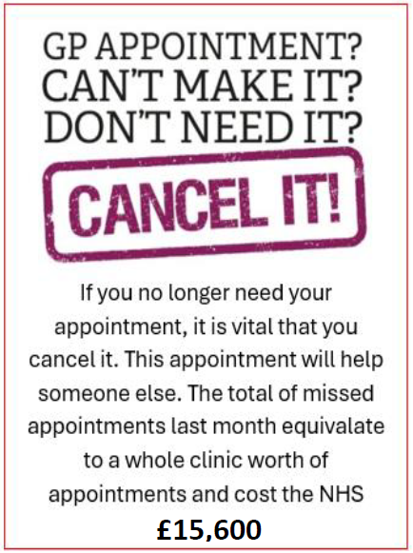





**£12,000**



You will be contacted from Newbury Group Practice via email going forward. Please make sure you update us with your preferred email address. The only text message you will receive from us now will be the one containing the self-book link for appointments. Please check your junk mail too if you have not received it in your inbox.



If you are eligible for the flu jab, please remember to call us or come to reception to book in.



If you have a long-term condition and have not had your annual review, please contact us so we can get you booked in.



**Monthly campaigns**

We are supporting Breast Cancer awareness month at the practice. You can donate £2 to buy a ribbon pin to show your support of this worthy charity.



**Childhood immunisations**



Is your child all set for preschool? Book your child the 4-in-1 preschool booster to help protect your child against serious illnesses

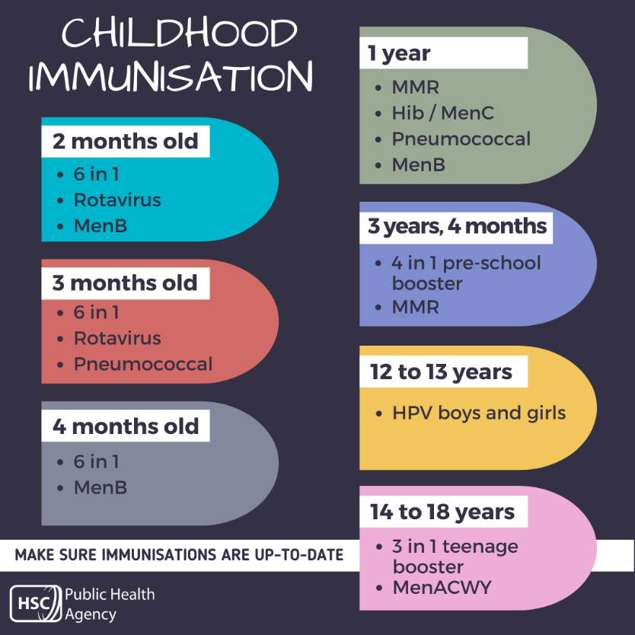

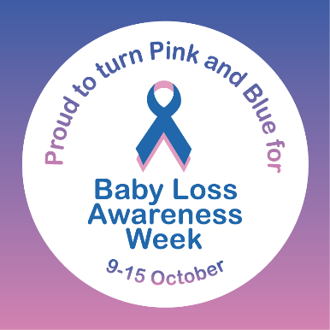





**Midwife Services**

We no longer have antenatal midwife services in this centre.

The new venue for this is

**Ilford Exchange Centre – Level 3**

**Unit 100**

**Ilford Exchange High Road, Ilford, IG1 1AT**