Telephone recording

privacy notice

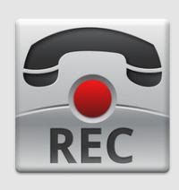

Why we process your information
We may record telephone calls you make to the surgery to :
- Adhere to quality assurance
- Train staff
- Prevent, detect, investigate any problems that may arise
- Provide an independent record of the discussion that took place.
It is important that the practice provides quality information to patients on their queries or bookings and that customer service standards are adhered to. This includes ensuring that key information is given to the patient as part of a telephone consultation with the Doctor or Nurse . We do this in the interests of offering a good service to our patients.
If you object to this, you will need to end the call when you are told that calls may be recorded. Alternative methods of communication are available.
Your information will not be transferred outside European Economic Area.

Sharing your call recording
Your call recording will not be shared with any other organisation unless they have a legal right to it.

How long we keep your call recording

We will delete call recordings 6 months after the call was made. This ensures that any investigations can be completed.

Your rights
The information you provided will be managed as required by Data Protection law. You have the right to receive a copy of the call recording. From 25 May 2018, you have the right to request that the call recording be deleted if you believe we are processing it for longer than necessary.

